Module 7) JQuery Basic, Effects & Advanced

**Q-1   What is jQuery?**

**Ans**.  JQuery is an in-built  Library of JavaScript . JQuery greatly simplifies JavaScript programming. JQuery is easy to learn.

         JQuery is a lightweight, "write less, do more"JavaScript library.

        The purpose of jQuery is to make it much easier to use JavaScript on your website.

       JQuery takes a lot of common tasks that require many lines of JavaScript code to    accomplish, and wraps them into methods that you can call with a single line of code.

      JQuery also simplifies a lot of the complicated things from JavaScript, like AJAX calls and DOM manipulation.

**Q-2   How to Apply CSS Using JQuery, How to Add Class and Remove Class in Jquery, JQuery Animation?**

**Ans.**

**Apply CSS using JQuery:**

**<!DOCTYPE html>**

**<html lang="en">**

**<head>**

**<meta charset="UTF-8">**

**<meta name="viewport" content="width=device-width, initial-scale=1.0">**

**<title>Document</title>**

**<script src="https://cdnjs.cloudflare.com/ajax/libs/jquery/3.7.0/jquery.min.js"></script>**

**</head>**

**<body>**

**<div>WELCOME</div>**

**<button>Submit</button>**

**<script>**

**$(document).ready(function () {**

**$("button").click(function () {**

**$("div").css({**

**"background-color": "red",**

**"color": "blue",**

**"font-size": "50px",**

**});**

**});**

**});**

**</script>**

**</body>**

**</html>**

**Output:**

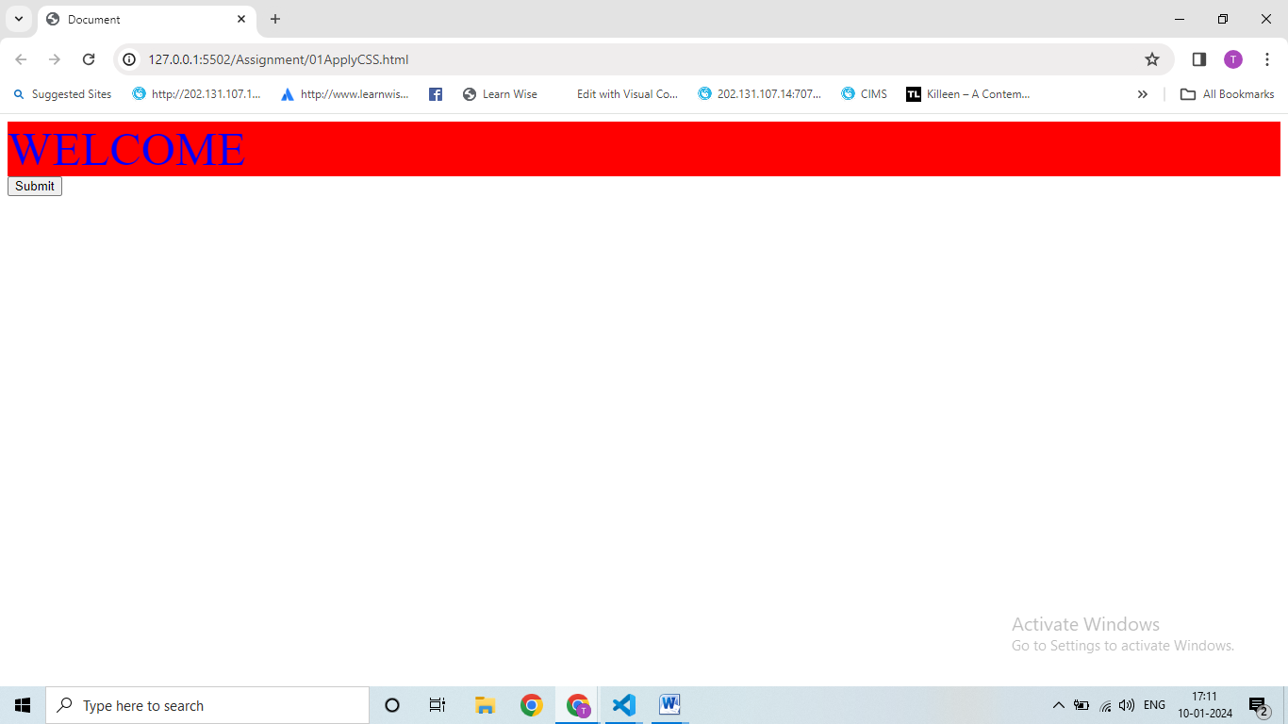

**Apply Add Class:**

**<!DOCTYPE html>**

**<html lang="en">**

**<head>**

**<meta charset="UTF-8">**

**<meta name="viewport" content="width=device-width, initial-scale=1.0">**

**<title>Document</title>**

**<script src="https://cdnjs.cloudflare.com/ajax/libs/jquery/3.7.0/jquery.min.js"></script>**

**<style>**

**.addnew {**

**font-size: 50px;**

**color: blue;**

**background-color: cyan;**

**}**

**</style>**

**</head>**

**<body>**

**<div>WELCOME</div>**

**<button>Click Here</button>**

**<script>**

**$(document).ready(function () {**

**$("button").click(function () {**

**$("div").addClass("addnew");**

**});**

**});**

**</script>**

**</body>**

**</html>**

**Apply Remove Class:**

**<!DOCTYPE html>**

**<html lang="en">**

**<head>**

**<meta charset="UTF-8">**

**<meta name="viewport" content="width=device-width, initial-scale=1.0">**

**<title>Document</title>**

**<script src="https://cdnjs.cloudflare.com/ajax/libs/jquery/3.7.0/jquery.min.js"></script>**

**<style>**

**.remove {**

**font-size: 50px;**

**color: red;**

**background-color: yellow;**

**}**

**</style>**

**</head>**

**<body>**

**<div class="remove">Namste</div>**

**<button>zxc</button>**

**<script>**

**$(document).ready(function () {**

**$("button").click(function () {**

**$("div").removeClass("remove");**

**});**

**});**

**</script>**

**</body>**

**</html>**

**JQuery Animation:**

**<!DOCTYPE html>**

**<html lang="en">**

**<head>**

**<meta charset="UTF-8">**

**<meta name="viewport" content="width=device-width, initial-scale=1.0">**

**<title>Document</title>**

**<script src="https://cdnjs.cloudflare.com/ajax/libs/jquery/3.7.0/jquery.min.js"></script>**

**<style>**

**div {**

**height: 100px;**

**width: 100px;**

**background-color: green;**

**position: relative;**

**}**

**</style>**

**</head>**

**<body>**

**<div>Hello</div>**

**<button>Submit</button>**

**<script>**

**$(document).ready(function () {**

**$("button").click(function () {**

**$("div").animate({ left: "500px" }),**

**$("div").animate({ top: "200px" });**

**$("div").animate({ left: "0px" });**

**});**

**});**

**</script>**

**</body>**

**</html>**

**Output:**

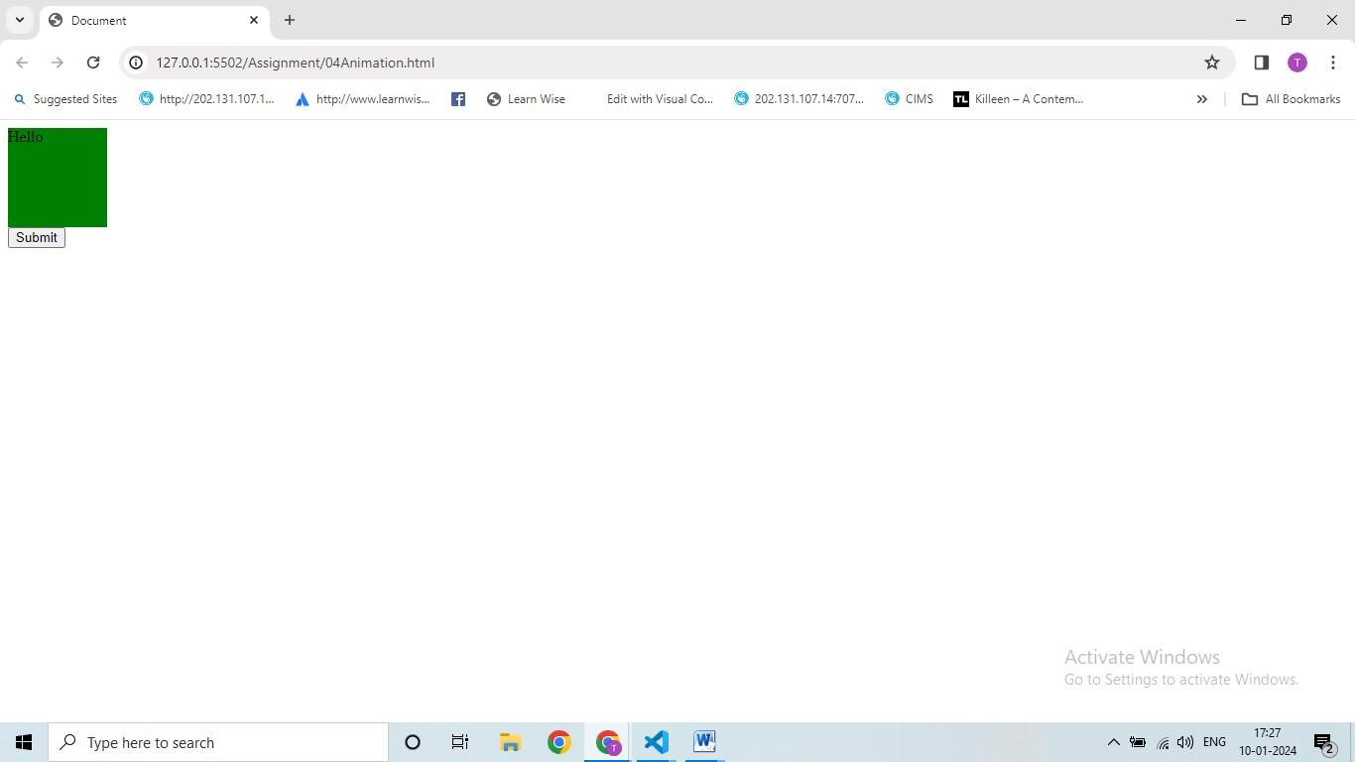

**Q-3  How to create a slider with animation?**

**Ans.**

**<!DOCTYPE html>**

**<html lang="en">**

**<head>**

**<meta charset="UTF-8" />**

**<meta http-equiv="X-UA-Compatible" content="IE=edge" />**

**<meta name="viewport" content="width=device-width, initial-scale=1.0" />**

**<title>Document</title>**

**<script src="https://cdnjs.cloudflare.com/ajax/libs/jquery/3.7.0/jquery.min.js"></script>**

**<style>**

**div {**

**height: 200px;**

**background-color: yellowgreen;**

**}**

**</style>**

**</head>**

**<body>**

**<div id="one1">1</div>**

**<div id="one2">2</div>**

**<script>**

**$(document).ready(function () {**

**$("#one1").click(function () {**

**$("#one2").slideToggle(3000);**

**});**

**});**

**</script>**

**</body>**

**</html>**

**Output:**

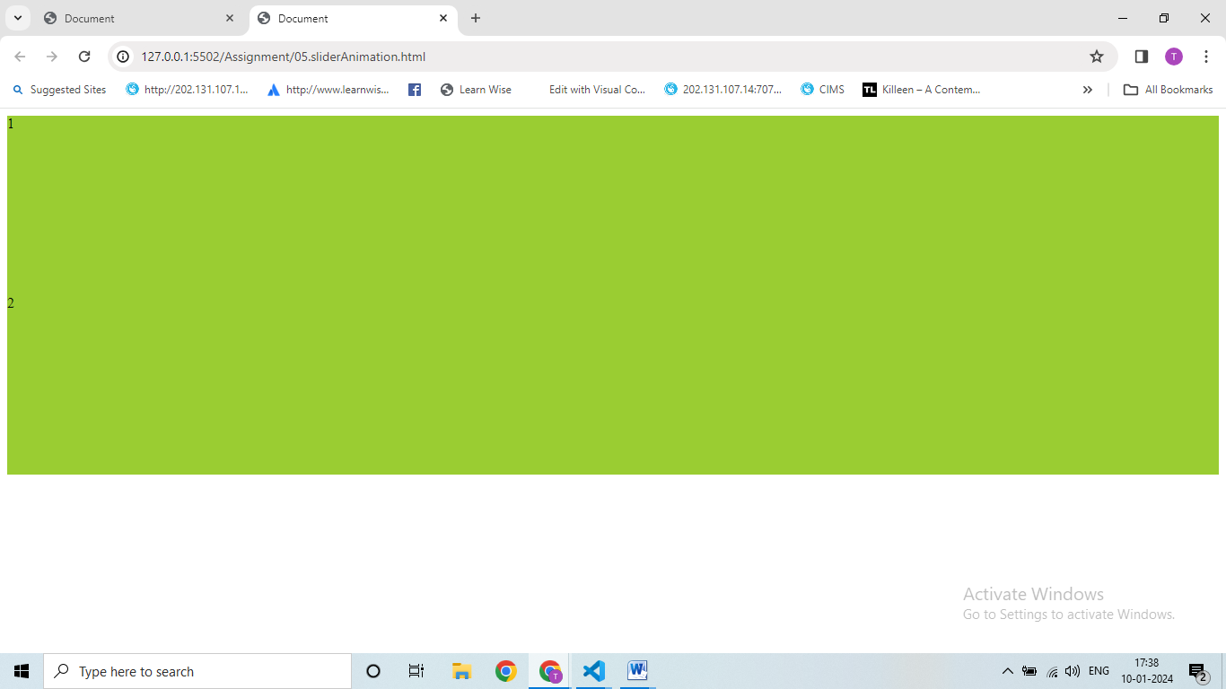

**Q-4  Event bubbling tickling example .**

**Ans.**

**<!DOCTYPE html>**

**<html lang="en">**

**<head>**

**<meta charset="UTF-8">**

**<meta name="viewport" content="width=device-width, initial-scale=1.0">**

**<title>Document</title>**

**<script src="https://cdnjs.cloudflare.com/ajax/libs/jquery/3.7.0/jquery.min.js"></script>**

**<script>**

**$(document).ready(function () {**

**$("span").parent().css({ border: "2px solid blue" });**

**$("span").parentsUntil().css({ border: "2px solid red" });**

**});**

**</script>**

**<style>**

**body * {**

**border: 2px solid black;**

**display: block;**

**padding: 20px;**

**}**

**</style>**

**</head>**

**<body>**

**<div> body (great-great-grandparent)**

**<div>div (great-grandparent)**

**<ul>ul (grandparent)**

**<li>li (direct-parent)**

**<span>span</span>**

**</li>**

**</ul>**

**</div>**

**</div>**

**</body>**

**</html>**

**Output:**

